Auto Guide On The Fly Description

This application modifies TSX autoguide settings while autoguiding is underway.

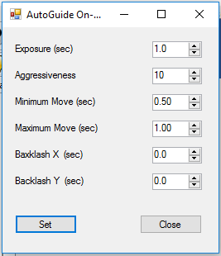

Requirements:

Auto Guide On The Fly is a Windows Forms executable, written in Visual Basic. TSX Camera Add On option is required. The application runs as a uncertified, standalone application under Windows 7, 8 and 10.

Installation:

Download the AGOnTheFly_Exe.zip and open. Run the "Setup" application. Upon completion, an application icon will have been added to the start menu under the category "TSXToolkit" with the name "Auto Guide On The Fly". This application can be pinned to the Start if desired.

Operation:

While autoguiding is underway, any setting can be modified, then “'Set". Initially the current autoguiding settings are downloaded from TSX. When 'Set' is clicked, autoguiding is momentarily aborted, the new settings uploaded, and autoguiding resumed..

For the AG On the Fly applet to work correctly:

1. The Sky X Pro Ver 10.3.0 (DB 9051 or greater) with CAO must be running

2. The Telescope and Guider must be connected

3. AutoGuiding must be initialized and running.

Support:

This application was written for the public domain and as such is unsupported. The developer wishes you his best and hopes everything works out, but recommends learning Visual Basic (it's really not hard and the tools are free from Microsoft) if you find a problem or want to add features. The source is supplied as a Visual Studio project.